Introduction to Dental
Anatomy
Formation of the Dentitions
(Overview)

Humans have two sets of teeth in their lifetime. The first set of teeth to be seen in the mouth is the primary or deciduous dentition, which begins to form prenatally at about 14 weeks in utero and is completed postnatally at about 3 years of age. In the absence of congenital disorders, dental disease, or trauma, the first teeth in this dentition begin to appear in the oral cavity at the mean age of 6, and the last emerge at a mean age of 28 ± 4 months. The deciduous dentition remains intact (barring loss from dental caries or trauma) until the child is about 6 years of age. At about that time the first succedaneous or permanent teeth begin to emerge into the mouth. The emergence of these teeth begins the transition or mixed dentition period in which there is a mixture of deciduous and succedaneous teeth present. The transition period lasts from about 6 to 12 years of age and ends when all the deciduous teeth have been shed. At that time the permanent dentition period begins. Thus, the transition from the primary dentition to the permanent dentition
begins with the emergence of the first permanent molars, shedding of the deciduous incisors, and emergence of the
permanent incisors. The mixed dentition period is often a difficult time for the young child because of habits, missing
teeth, teeth of different colors and hues, crowding of the teeth, and malposed teeth.
After the shedding of the deciduous canines and molars, emergence of the permanent canines and premolars, and
emergence of the second permanent molars, the permanent dentition is completed (including the roots) at about 14 to
15 years of age, except for the third molars, which are completed at 18 to 25 years of age. In effect, the duration of the
permanent dentition period is 12+ years. The completed permanent dentition consists of 32 teeth if none are congenitally missing, which may be the case.

Nomenclature
The first step in understanding dental anatomy is to learn the nomenclature, or the system of names, used to describe
or classify the material included in the subject. When a significant term is used for the first time here, it is emphasized in bold. Additional terms will be discussed as needed in subsequent chapters.
The term mandibular refers to the lower jaw, or mandible. The term maxillary refers to the upper jaw, or maxilla. When more than one name is used in the literature to describe something, the two most commonly used names will be used initially. After that they may be combined or used separately as consistent with the literature of a particular specialty of dentistry, for example, primary or deciduous dentition, permanent or succedaneous dentition. A good case may be made for the use of both terms. By dictionary definition,1 the term primary can mean “constituting or belonging to the first stage in any process.” The term deciduous can mean “not permanent, transitory.” The same unabridged dictionary refers the reader from the definition of deciduous tooth to milk tooth, which is defined as “one of the temporary teeth of a mammal that are replaced by permanent teeth. Also called baby tooth, deciduous tooth.” The term primary can indicate a first dentition and the term deciduous can indicate that the first dentition is not permanent, but not unimportant. The term succedaneous can be used to describe a successor dentition and does not suggest permanence, whereas the term permanent suggests a permanent dentition, which may not be the case due to dental caries, periodontal diseases, and trauma. All four of these descriptive terms appear in theprofessional literature.

Formulae for Mammalian Teeth
The denomination and number of all mammalian teeth are expressed by formulae that are used to differentiate the
human dentitions from those of other species. The denomination of each tooth is often represented by the initial letter
in its name (e.g., I for incisor, C for canine, P for premolar, M for molar). Each letter is followed by a horizontal line
and the number of each type of tooth is placed above the line for the maxilla (upper jaw) and below the line for the
mandible (lower jaw). The formulae include one side only, with the number of teeth in each jaw being the same for
humans.
The dental formula for the primary/deciduous teeth in
humans is as follows:

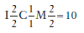
This formula should be read as: incisors, two maxillary and two mandibular; canines, one maxillary and one mandibular; molars, two maxillary and two mandibular—or 10 altogether on one side, right or left (Figure 1-2, A).
A dental formula for the permanent human dentition is as follows:

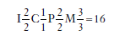

Premolars have now been added to the formula, twomaxillary and two mandibular, and a third molar has been
added, one maxillary and one mandibular (Figure 1-2, B).Systems for scoring key morphological traits of the permanent
dentition that are used for anthropological studies are not described here.

Tooth Numbering Systems
In clinical practice some “shorthand” system of tooth notation is necessary for recording data. There are several
systems in use in the world, but only a few are considered here. In 1947 a committee of the American Dental Association (ADA) recommended the symbolic (Zsigmondy/Palmer) system as the numbering method of choice.3 However, because of difficulties with keyboard notation of the symbolic notation system, the ADA in 1968 officially recommended the “universal” numbering system. Because of some limitations and lack of widespread use internationally, recommendations for a change sometimes are made.4 The universal system of notation for the primary dentition uses uppercase letters for each of the primary teeth: For the maxillary teeth, beginning with the right second molar, letters A through J, and for the mandibular teeth, letters K through T, beginning with the left mandibular second
molar. The universal system notation for the entire primary dentition is as follows:

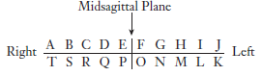

The symbolic system for the permanent dentition was introduced by Adolph Zsigmondy of Vienna in 1861
and then modified for the primary dentition in 1874.
1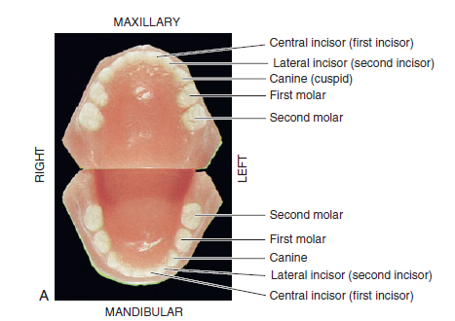
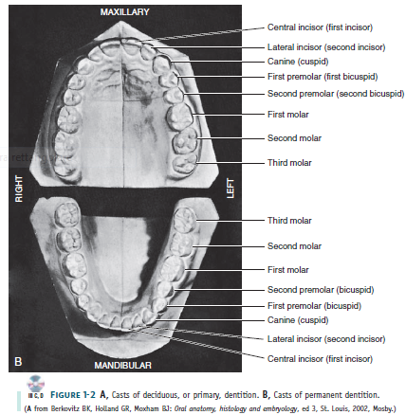
Independently, Palmer also published the symbolic system in 1870. The symbolic system is most often referred to as
the Palmer notation system in the United States and less frequently as the Zsigmondy/Palmer notation system. In this system the arches are divided into quadrants with the entire
dentition being notated as follows:

Thus, for a single tooth such as the maxillary right central incisor the designation is A . For the mandibular left central
incisor, the notation is given as A . This numbering system presents difficulty when an appropriate font is not available
for keyboard recording of Zsigmondy/Palmer symbolic notations. For simplification this symbolic notation is often
designated as Palmer’s dental notation rather than Zsigmondy/ Palmer notation.
In the universal notation system for the permanent dentition, the maxillary teeth are numbered from 1 through 16,
beginning with the right third molar. Beginning with the mandibular left third molar, the teeth are numbered 17
through 32. Thus, the right maxillary first molar is designated as 3, the maxillary left central incisor as 9, and the
right mandibular first molar as 30. The following universal notation designates the entire permanent dentition.

The Zsigmondy/Palmer notation for the permanent dentition is a four-quadrant symbolic system in which, beginning
with the central incisors, the teeth are numbered 1 through 8 (or more) in each arch. For example, the right
maxillary first molar is designated as 6 , and the left mandibular central incisor as 1 . The Palmer notation for the
entire permanent dentition is as follows:

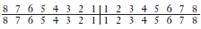

Viktor Haderup of Denmark in 1891 devised a variant of the eight-tooth quadrant system in which plus (+) and minus
(−) were used to differentiate between upper and lower quadrants and between right and left quadrants; in other
words, +1 indicates the upper left central incisor and 1− indicates the lower right central incisor. Primary teeth were
numbered as follows: upper right, 05+ to 01+; lower left,−01 to −05. This system is still taught in Denmark.5
The universal system is acceptable to computer language, whereas the Palmer notation is generally incompatible with
computers and word processing systems. Each tooth in the universal system is designated with a unique number, which
leads to less confusion than with the Palmer notation. A two-digit system proposed by Fédération Dentaire
Internationale (FDI) for both the primary and permanent dentitions has been adopted by the World Health Organization
and accepted by other organizations such as the International Association for Dental Research. The FDI system
of tooth notation is as follows.
For the primary teeth:

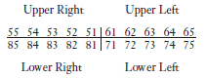

Numeral 5 indicates the maxillary right side, and 6 indicates the maxillary left side. The second number of
the two-digit number is the tooth number for each side. The number 8 indicates the mandibular right side, and
the number 7 indicates the mandibular left side. The second number of the two-digit system is the tooth number. Thus,
for example the number 51 refers to the maxillary right central incisor.
For the permanent teeth:

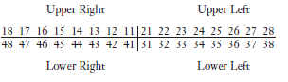
Thus, as in the two-digit FDI system for the primary dentition, the first digit indicates the quadrant: 1 to 4 for
the permanent dentition and 5 to 8 for the primary dentition. The second digit indicates the tooth within a quadrant:
1 to 8 for the permanent teeth and 1 to 5 for the primary teeth. For example, the permanent upper right central
incisor is 11 (pronounced “one one,” not “eleven”).

THE CROWN AND ROOT
Each tooth has a crown and root portion. The crown is covered with enamel, and the root portion is covered with
cementum. The crown and root join at the cementoenamel junction (CEJ). This junction, also called the cervical line
(Figure 1-3), is plainly visible on a specimen tooth. The main bulk of the tooth is composed of dentin, which is clear
in a cross section of the tooth. This cross section displays a pulp chamber and a pulp canal, which normally contain the
pulp tissue. The pulp chamber is in the crown portion mainly, and the pulp canal is in the root (Figure 1-4).The
spaces are continuous with each other and are spoken of collectively as the pulp cavity.
The four tooth tissues are enamel, cementum, dentin, and pulp. The first three are known as hard tissues, the last
as soft tissue. The pulp tissue furnishes the blood and nerve supply to the tooth. The tissues of the teeth must be considered in relation to the other tissues of the orofacial structures (Figures 1-5 and 1-6) if the physiology of the teeth is to be understood

The crown of an incisor tooth may have an incisal ridge or edge, as in the central and lateral incisors; a single cusp,
as in the canines; or two or more cusps, as on premolars and molars. Incisal ridges and cusps form the cutting surfaces on tooth crowns. The root portion of the tooth may be single, with one apex or terminal end, as usually found in anterior teeth andsome of the premolars; or multiple, with a bifurcation or trifurcation dividing the root portion into two or more
extensions or roots with their apices or terminal ends, as found on all molars and in some premolars.
The root portion of the tooth is firmly fixed in the bony process of the jaw, so that each tooth is held in its position
relative to the others in the dental arch. That portion of the jaw serving as support for the tooth is called the alveolar
process. The bone of the tooth socket is called the alveolus
(plural, alveoli) (Figure 1-7). The crown portion is never covered by bone tissue after
it is fully erupted, but it is partly covered at the cervical third in young adults by soft tissue of the mouth known as the
gingiva or gingival tissue, or “gums.” In some persons, all of the enamel and frequently some cervical cementum may not be covered by the gingiva.
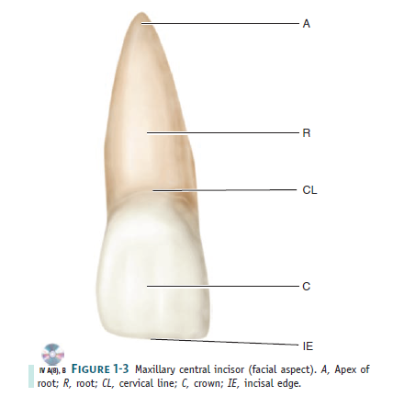
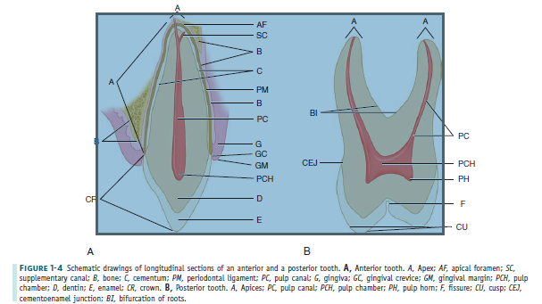

SURFACES AND RIDGES
The crowns of the incisors and canines have four surfaces and a ridge, and the crowns of the premolars and molars
have five surfaces. The surfaces are named according to their positions and uses (Figure 1-8). In the incisors and
canines, the surfaces toward the lips are called labial surfaces; in the premolars and molars, those facing the cheek are
the buccal surfaces. When labial and buccal surfaces are spoken of collectively, they are called facial surfaces. All
surfaces facing toward the tongue are called lingual surfaces. The surfaces of the premolars and molars that come
in contact (occlusion) with those in the opposite jaw during the act of closure are called occlusal surfaces. These are called incisal surfaces with respect to incisors and canines. The surfaces of the teeth facing toward adjoining teeth
in the same dental arch are called proximal or proximate surfaces. The proximal surfaces may be called either mesial or distal. These terms have special reference to the position of the surface relative to the median line of the face. This line is drawn vertically through the center of the face, passing between the central incisors at their point of contact with
each other in both the maxilla and the mandible. Those proximal surfaces that, following the curve of the arch, are
faced toward the median line are called mesial surfaces, and those most distant from the median line are called distal
surfaces. Four teeth have mesial surfaces that contact each other: the maxillary and mandibular central incisors. In all other instances, the mesial surface of one tooth contacts the distal surface of its neighbor, except for the distal surfaces of third molars of permanent teeth and distal surfaces of second molars in deciduous teeth, which have no teeth distal to them. The area of the mesial or distal surface of a tooth that touches its neighbor in the arch is called the contact area. Central and lateral incisors and canines as a group are called anterior teeth; premolars and molars as a group, posterior teeth.
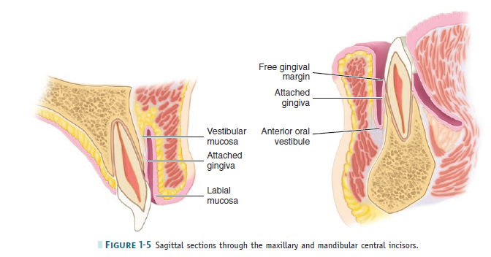
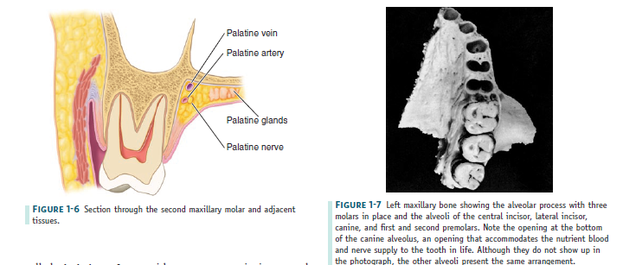
OTHER LANDMARKS
To study an individual tooth intelligently, one should recognize all landmarks of importance by name. Therefore, at
this point it is necessary to become familiar with additional terms, such as the following:
A cusp is an elevation or mound on the crown portion of a tooth making up a divisional part of the occlusal surface
(Figures 1-4 and 1-9).
A tubercle is a smaller elevation on some portion of the crown produced by an extra formation of enamel (see Figure
4-14, A). These are deviations from the typical form.
A cingulum (Latin word for “girdle”) is the lingual lobe of an anterior tooth. It makes up the bulk of the cervical third
of the lingual surface. Its convexity mesiodistally resembles a girdle encircling the lingual surface at the cervical third
(see Figures 1-10 and 4-13, A).
A ridge is any linear elevation on the surface of a tooth and is named according to its location (e.g., buccal ridge,
incisal ridge, marginal ridge).
Marginal ridges are those rounded borders of the enamel that form the mesial and distal margins of the occlusal
surfaces of premolars and molars and the mesial and distal margins of the lingual surfaces of the incisors and canines
( Figures 1-10, A, and 1-11 ).
Triangular ridges descend from the tips of the cusps of molars and premolars toward the central part of the occlusal
surfaces. They are so named because the slopes of each side of the ridge are inclined to resemble two sides of a triangle
( Figures 1-11, B and C, and 1-12 ). They are named after the cusps to which they belong, for example, the triangular ridge of the buccal cusp of the maxillary fi rst premolar. When a buccal and a lingual triangular ridge join, they
form a transverse ridge. A transverse ridge is the union of two triangular ridges crossing transversely the surface of a posterior tooth ( Figure 1-11, B and C ).
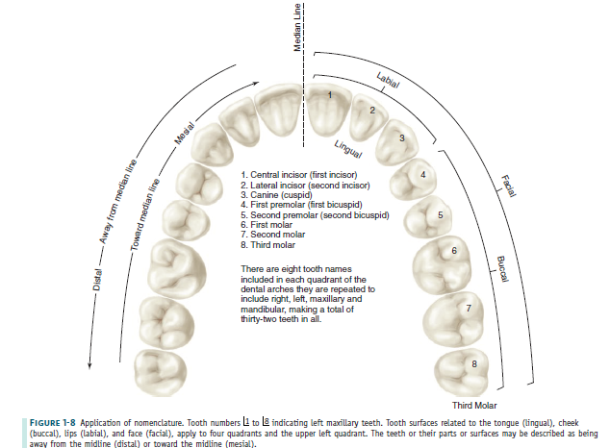

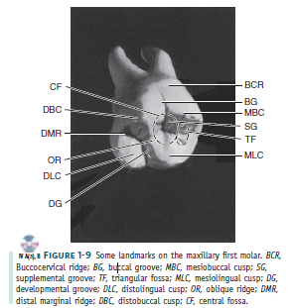

The oblique ridge is a ridge crossing obliquely the occlusal surfaces of maxillary molars and formed by the union of the triangular ridge of the distobuccal cusp and the distal cusp ridge of the mesiolingual cusp ( Figure 1-9 ).
A fossa is an irregular depression or concavity. Lingual fossae are on the lingual surface of incisors ( Figure 1-10 ).
Central fossae are on the occlusal surface of molars. They are formed by the convergence of ridges terminating at a central point in the bottom of the depression where there is a junction of grooves ( Figure 1-12 ). Triangular fossae are found on molars and premolars on the occlusal surfaces mesial or distal to marginal ridges ( Figure 1-9 ). They are sometimes found on the lingual surfaces of maxillary incisors at the edge of the lingual fossae where the marginal ridges and the cingulum meet (see Figure 4-14, A ).
A sulcus is a long depression or valley in the surface of a tooth between ridges and cusps, the inclines of which meet
at an angle. A sulcus has a developmental groove at the junction of its inclines. (The term sulcus should not be confused
with the term groove .)
A developmental groove is a shallow groove or line between the primary parts of the crown or root. A supplemental groove, less distinct, is also a shallow linear depression on the surface of a tooth, but it is supplemental to a developmental groove and does not mark the junction of primary parts. Buccal and lingual grooves are developmental grooves found on the buccal and lingual surfaces of posterior teeth (Figures 1-9
and 1-12).
Pits are small pinpoint depressions located at the junction of developmental grooves or at terminals of those grooves.
For instance, central pit is a term used to describe a landmark in the central fossa of molars where developmental grooves join (Figure 1-11, C).
A lobe is one of the primary sections of formation in the development of the crown. Cusps and mamelons are representative of lobes. A mamelon is any one of the three rounded protuberances found on the incisal ridges of newly erupted incisor teeth (Figure 1-10, B). (For further description of
lobes, see Figures 4-11 through 4-14).
The roots of the teeth may be single or multiple. Both maxillary and mandibular anterior teeth have only one root
each. Mandibular first and second premolars and the maxillary second premolar are single rooted, but the maxillary
first premolar has two roots in most cases, one buccal and one lingual. Maxillary molars have three roots, one mesiobuccal, one distobuccal, and one lingual. Mandibular molars have two roots, one mesial and one distal. It must be understood that description in anatomy can never follow a hardand- fast rule. Variations frequently occur. This is especially true regarding tooth roots, for example, facial and lingual roots of the mandibular canine.

