Pulp Chambers and Canals
The terminology and essential features of the pulp chambers and pulp canals are considered before presenting the details of pulp chambers and canals using sectioned tooth specimens. Then a brief section on radiographic visualization of pulp chambers and canals is provided. After that a short section is presented on crown and root fractures. A final
section considers the relationship of the teeth to the mandibular canal. The use of the term pulp chamber, pulp cavity, or coronal pulp to designate that part of the crown normally filled with soft tissue varies with the anatomist; however, as with the terms root pulp and radicular pulp, and pulp canal and root canal, it is probably a matter of professional preference, because a good case can be made for each of the terms.
These two sets of terms relating to crown and root are used as if they have the same meaning, with the recognition that
arguably there may be contextualized differences.
Pulp, Chamber, and Canals
The crown and root portion of a tooth that contains the pulp tissues has been arbitrarily divided into the pulp chamber
and the root or pulp canal (Figure 13-1). The complexities ofthese cavities cannot be fully appreciated without studying
longitudinal and transverse sections of each of the representative types of teeth.
The dental pulp is the soft tissue component of the tooth. It occupies the internal cavities of the tooth (i.e., the pulp
chamber and pulp canal). In general, the outline of the pulp tissue corresponds to the external outline form of the tooth
(i.e., the outline form of the pulp chamber corresponds with the shape of the crown, whereas the outline form of
the pulp canal corresponds with the shape of the roots of a tooth).
The dental pulp within these cavities originates from the mesenchyme and has been assigned a number of different
functions: formative, nutritive, sensory, and defensive. The initial function of the dental pulp is the formation of dentin
during the developmental period. The complex sensory system within the dental pulp controls the blood flow and
is responsible for at least mediation of the sensation of pain.
The formation of reparative dentin or secondary dentition (osteoid-like dentin) represents a defensive response to any
form of irritation, whether it is mechanical, thermal, chemical, or bacterial. The reactive dentin is usually limited to
the area of pulpal irritation. Separating reactive changes (response to injury) from purely aging-related changes may
be difficult or impossible to do at this time.
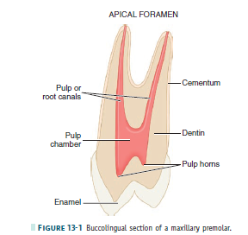

Radiographs
The use of radiographs or digital radiography for the diagnosis and treatment of pulpal disease requires that the morphological features of the pulp chambers and root canals, which are three-dimensional, be visualized when compressed into a “two-dimensional” radiographic image. Thus, radiographic views taken of the teeth from a facial orientation show a monoplane, buccolingual view of the hard tooth structures and radiolucent spaces for the pulp and canals (Figure 13-2). Mesiodistal aspects of longitudinal sections usually are seen only incidentally (e.g., on radiographs of malposed, rotated teeth). Thus, the radiographic anatomy of the pulp cavity from a mesial-distal aspect is not well
known. Radiographic views of the pulp chambers and canals will be considered in more detail later.
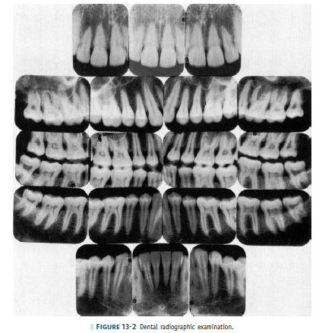
SIZE OF THE PULP CAVITY
The size of the pulp chamber depends on the age of the tooth and its history of trauma. Secondary dentin is formed
continuously throughout the life of the tooth as a normal process, as long as the vitality of the tooth is maintained.
The formation of secondary dentin is not uniform, because the odontoblasts adjacent to the floor and roof of the
pulp cavity produce greater quantities of secondary dentin than do the odontoblasts located adjacent to the walls of
the pulp cavity.1 Therefore the size of the pulp cavity is much larger in a young individual than in an adult (Figure
13-3, A and B) and should be considered before extensive tooth reduction is accomplished, especially in a young
person. Various traumatic injuries occur that, if severe enough, will initiate a different type of dentin formation. Irritationinduced or reparative dentin may be formed in response to the carious process, abrasion, and attrition, as well as to operative procedures. This response is protective but may ultimately be detrimental in later years, because a finite
amount of space is present within the pulp cavity. The size of the pulp cavity in a given tooth should be compared with
that in the other teeth. If the calcification demonstrated is a localized phenomenon and is extensive, elective endodon-
tic therapy is strongly suggested before any restorative pro cedure. Elective endodontics should be considered when
extreme calcification is present in a tooth scheduled for complex restorative procedures.

Foramen
The neurovascular bundle, which supplies the internal contents of the pulp cavity, enters through the apical foramen
or foramina (see Figure 13-1). As the root begins to develop, the apical foramen is actually larger than the pulp chamber
(Figure 13-4, 1), but it becomes more constricted at the completion of root formation (Figure 13-4, 2 through
5). It is possible for any root of a tooth to have multiple apical foramina. If these openings are large enough, the
space that leads to the main root canal is called a supplementary or lateral canal (Figure 13-5). If the root canal breaks up into multiple tiny canals, it is referred to as a delta system2
because of its complexity (Figure 13-6).

Demarcation of Pulp Cavity and Canal
The cementoenamel junction (CEJ) is not quite at the level at which the root canal becomes the pulp chamber (see
Figure 13-1). This demarcation is mainly macroscopically based but may be visualized by exploring the CEJ (see Figure
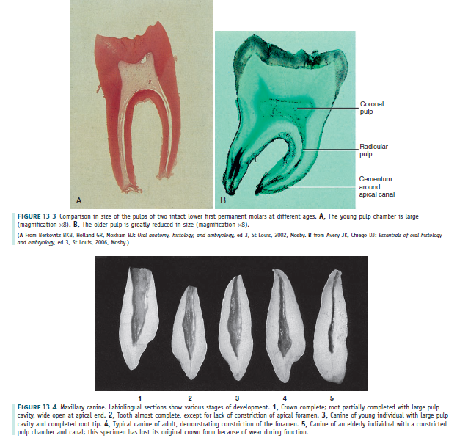
2-16) and noting the difference in density between the enamel and dentin at the mesial and distal tooth surfaces on
radiographs. Enamel covers the external surface of the dentin, which makes up part of the pulp chamber, whereas
cementum covers the entire external dentinal surface of the root canal space. The demarcation is simpler in multirooted
teeth, because the pulp cavity within the root is the root canal and the remaining pulp cavity is the pulp chamber. Microscopically, the pulp within the chamber appears to be more cellular than the pulp found within
the pulp of the root canal. The odontoblasts are cuboidal in the coronal pulp chamber but gradually flatten out as
the apex is approached. The transition from the pulp chamber to the root canal is not sharply demarcated
microscopically, and this demarcation is not sharply delineated macroscopically.
Pulp Horns
Projections or prolongations in the roof of the pulp chamber correspond to the various major cusps or lobes of the crown. The pulpal tissues that occupy these prolongations are called pulp horns (Figure 13-7). The prominence of the cusps or lobes corresponds with the development of the pulp horns. If the cusps or labial lobes are prominent (as in young individuals), one should expect to find equally prominent pulp horns underlying these structures (see Figure 13-8, B, 6). These projections become less prominent with time as a result of the formation of secondary dentin (see Figure 13-8, B, 1).
Clinical Applications
One of the primary functions of the dentist is to prevent, intercept, and treat diseases or disorders affecting the dentition.
It is also essential that the clinician be aware of the location and size of the pulp cavities during operative procedures
to prevent unnecessary encroachment on the pulp. It is also incumbent on the clinician to know the location of the
location and size of the pulp cavities during operative procedures
to prevent unnecessary encroachment on the pulp.
It is also incumbent on the clinician to know the location of the mandibular canal and nerve.
Endodontic procedures also require a thorough knowledge of the pulp cavity. Perforation during access preparation,
failure to locate all the canals, or perforation of the root surface may result in the ultimate loss of the tooth.
Therefore the clinician performing endodontics must know the size and location of the pulp chamber and the expected
number of roots and canals. Radiographic detection of all accessory roots or canals may not be possible, although some evidence is present based on the shape of the crown that additional canals are present. Even so, the clinician must recognize some of the internal signs of additional canals during the endodontic procedure. With a thorough knowledge of the pulp cavities in the permanent dentition, prevention, interception, and treatment of dentition-related disease processes will be accomplished with a greater degree of success.

