The Mandible
The mandible (Figures 14-12 through 14-23) is horseshoeshaped and supports the teeth of the lower dental arch. This
bone is movable and has no bony articulation with the skull. It is the heaviest and strongest bone of the head and serves
as a framework for the floor of the mouth. It is situated immediately below the maxillary and zygomatic bone, and
its condyles rest in the mandibular fossa of the temporal bone. This articulation is the temporomandibular joint.
The mandible has a horizontal portion, or body, and two vertical portions, or rami. The rami join the body at an
obtuse angle. The body consists of two lateral halves, which are joined at the median line shortly after birth. The line of fusion, usually marked by a slight ridge, is called the symphysis. The body of the mandible has two surfaces, one external and one internal, and two borders, one superior and one inferior.
To the right and left of the symphysis, near the lower border of the mandible, are two prominences called mental
tubercles. A prominent triangular surface made by the

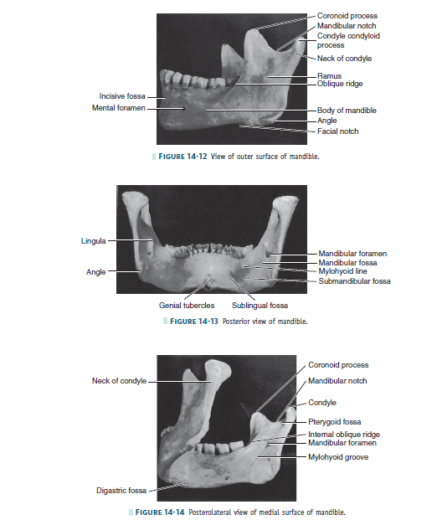
symphysis and these two tubercles is called the mental protuberance (see Figure 14-16).
Immediately posterior to the symphysis and immediately above the mental protuberance is a shallow depression called
the incisive fossa. The fossa is immediately below the alveolar border of the central and lateral incisors and anterior to
the canines. The alveolar portion of the mandible overlying the root of the canine is prominent and is called the canine
eminence of the mandible. However, this eminence does not
extend down very far toward the lower border of the mandible before it is lost in the prominence of the mental protuberance and the lower border of the mandible. The external surface of the mandible from a lateral
viewpoint presents a number of important areas for examination.
The oblique ridge (oblique line, radiographically) extends obliquely across the external surface of the mandible from
the mental tubercle to the anterior border of the ramus, with which it is continuous. It lies below the mental foramen. It
is usually not prominent except in the molar area (see Figure 14-12).
This ridge thins out as it progresses upward and becomes the anterior border of the ramus and ends at the tip of the
coronoid process. The coronoid process is one of two processes making up the superior border of the ramus. It is a
pointed, flattened, smooth projection and is roughened toward the tip to give attachment for a part of the temporal
muscle. The condyle, or condyloid process, on the posterior border of the ramus is variable in form. It is divided into a superior or articular portion and an inferior portion, or neck. Although the articular portion, the condyle, appears as a
rounded knob when the mandible is viewed from a lateral aspect, from a posterior aspect, the condyle is much wider
and oblong in outline (compare Figures 14-12 and 14-13). The condyle is convex above, fitting into the mandibular
fossa of the temporal bone when the mandible is articulated to the skull, and forms, with the interarticular cartilage that
lies between the two surfaces and with the tissue attachment, the temporomandibular joint (see Figure 15-2).
The neck of the condyle is a constricted portion immediately below the articular surface. It is flattened in front and
presents a concave pit medially, the pterygoid fovea. A smooth, semicircular notch, the mandibular notch, forms the sharp upper border of the ramus between the condyle and coronoid process (see Figure 14-14).
The distal border of the ramus is smooth and rounded and presents a concave outline from the neck of the condyle
to the angle of the jaw, where the posterior border of the ramus and the inferior border of the body of the mandible
join. The border of this angle is rough, being the attachment of the masseter muscle (see Figure 15-18) and the stylomandibular ligament (see Figure 15-7).
An important landmark on the lateral aspect of the mandible is the mental foramen. It should be noted that this
opening of the anterior end of the mandibular canal is directed upward, backward, and laterally. The foramen is
usually located midway between the superior and inferior border of the body of the mandible when the teeth are in
position, and most often, it is below the second premolar tooth, a little below the apex of the root. The position of
this foramen is not constant, and it may be between the first premolar and the second premolar tooth. After the teeth are
lost and resorption of alveolar bone has taken place, the mental foramen may appear near the crest of the alveolar
border. In childhood, before the first permanent molar has come into position, this foramen is usually immediately
below the first primary molar and nearer the lower border. It is interesting to note that when the mandible is observed
from a point directly opposite the first molar, most of the distal half of the third molar is hidden by the anterior border
of the ramus. When the mandible is viewed from in front, directly opposite the median line, the second and third
molars are located 5 to 7 mm lingually to the anterior border of the ramus (compare Figures 14-12 and 14-16).

INTERNAL SURFACE OF THE MANDIBLE
Observation of the mandible from the rear shows that the median line is marked by a slight vertical depression, representing the line of union of the right and left halves of the mandible, and that immediately below this, at the lower
third, the bone is roughened by eminences called the superior and inferior mental spines, or genial tubercles (see Figures 14-15 and 14-34, C).
The internal surface of the body of the mandible is divided into two portions by a well-defined ridge, the mylohyoid
line. It occupies a position closely corresponding to the lateral oblique ridge on the surface. It starts at or near the
lowest part of the mental spines and passes backward and upward, increasing in prominence until the anterior portion
of the ramus is reached; there, it smoothes out and gradually disappears (see Figures 14-14 and 14-34, C).
This ridge is the point of origin of the mylohyoid muscle, which forms the central portion of the floor of the mouth.
Immediately posterior to the median line and above the anterior part of the mylohyoid ridge a smooth depression,
the sublingual fossa, may be seen. The sublingual gland lies in this area.
A small, roughened oval depression, the digastric fossa, is found on each side of the symphysis immediately below the
mylohyoid line and extending onto the lower border. Toward the center of the body of the mandible, between
the mylohyoid line and the lower border of the bone, asmooth oblong depression is located, called the submandibular
fossa. It continues back on the medial surface of theramus to the attachment of the lateral pterygoid muscle.
The submandibular gland lies within this fossa.
The mandibular foramen is located on the medial surface of the ramus midway between the mandibular notch and the
angle of the jaw and also midway between the internal oblique line and the posterior border of the ramus. The
mandibular canal begins at this point, passing downward and forward horizontally.
The anterior margin of the foramen is formed by thelingula, or mandibular spine, which gives attachment to the
sphenomandibular ligament. Coming obliquely downward from the base of the foramen beneath the lingula is a decided groove, the mylohyoid groove. Behind this groove toward the angle of the mandible, a roughened surface for the attachment of the medial pterygoid muscle may be seen.

